***CSC 3020***

***Java Programming***

**Lab 06**

**25 points**

**Due 10:10 A.M.**

Assignment Objectives:

■■ To define a subclass from a superclass through inheritance.

■■ To invoke the superclass’s constructors and methods using the **super** keyword.

■■ To override instance methods in the subclass.

■■ To discover polymorphism and dynamic binding.

All labs must be submitted by the Canvas. **No email or hard copy** is accepted. You must follow the following format:

1. Submit your file to the Canvas. You must submit your file on time; otherwise, you will receive zero.
2. You can upload your file as many times as you like. Only the last attempt counts because the last file you uploaded is the only file your instructor will see.
3. There will be several modules on the Canvas. You need to upload your file using the correct module on the Canvas.
4. Name the lab file: *Lab (labt number)*
5. To upload your file(s):

* In Course Navigation, click the ASSIGNMENTS module.
* Click the title of the assignment.
* Click the **Submit** Assignment button.
* Add **File**. ...
* **Submit** Assignment. ...
* View **Submission**.

*It is your responsibility to make sure that the file is uploaded correctly. If you uploaded a wrong file, you receive zero; files will not be accepted after due date even if you have a prove that the file is created before the due date.*

***Make sure you review the Cheating & Plagiarism policy on Canvas.***

**Solution to this assignment will not be posted on Canvas; however, any question can be discussed in the class upon request of a student.**

Download class Point and class Circle from Canvas under Lab 6 link.

A point in the x-y plane is represented by its x-coordinate and y-coordinate. class Point stores a point in the x-y plane. Class Circle stores the radius and center of the circle and performs the usual operations on a circle, such as calculating the area and circumference. Because the center of the Circle is a point in the x-y plane, class Circle is derived from the class Point.

Every cylinder has a base and height, where the base is a circle. Create ***class Cylinder*** that has property height. Derive this class from the class Circle. Override toString and area methods.

The area of the Cylinder is :

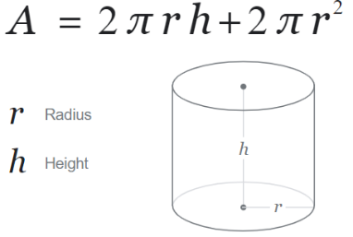

Write a test program (***TestCylinder***) that creates three reference variables types Object, Point, and Circle; initialize each reference variable with an instance of Cylinder. Invoke methods toString and area from each instance. ***Do not make any change in class Point or class Circle.***

*Submit two files: one file for class Cylinder and one file for class TestCylinder. Convert your files to .txt files.*

